**Task 3: Aasfa Saleem**

# Project: Development of a Mobile Application for a Fitness Company

Scope: Develop a mobile application for a fitness company that provides customized workout plans and nutrition advice to its customers. The application should have a user-friendly interface and allow customers to track their progress over time.

# Objectives:

Develop a mobile application that meets the fitness company's requirements

Launch the mobile application within the project timeline and budget

Ensure that the mobile application meets the required quality standards

Deliverables:

A fully functional mobile application that meets the fitness company's requirements

User manuals and training materials for the fitness company's staff

Documentation of the project process and outcomes

Timeline: 6 months

# Resource Allocation:

* Project Manager
* Mobile Application Developer
* Quality Assurance Specialist
* Graphic Designer
* Marketing Specialist

# Communication Plan:

* Weekly project team meetings
* Bi-weekly progress updates to stakeholders
* Monthly reports to the fitness company's management team

# Potential Risks:

* Delay in project timeline due to unforeseen technical issues
* Inadequate testing resulting in the launch of a defective application
* Insufficient resources allocated to the project resulting in poor quality outcomes
* Changes in the requirements of the fitness company resulting in project scope creep.

## **Task:**

Review the project scope, objectives, and deliverables for the mobile application project.

1. Develop a quality control plan for the project that includes risk management and project quality management elements to ensure that the mobile application meets the required quality standards.

**Quality Control Plan:**

To develop a quality control plan for this Mobile App we must arrange meetings with the stakeholders to ensure the quality of the App and discuss the features like about the fitness plans and tracking system to make the user-friendly and customize App according to their demand. Time-to-time meetings and progress report must be sent to them to maintain the quality of the App and the timeframe is 6 months in which we have to deal with the risks associated like delay in the delivery, Inadequate testing resulting, insufficient resources, requirements of the fitness company resulting in project scope creep.

**Metrics and procedures for quality tracking:**

**Resource Allocation for the quality App:** Project Manager, Mobile Application Developer, Quality Assurance Specialist, Graphic Designer and Marketing Specialist all are of good experience and having good communication between them to ensure the quality App.

**Functional testing:** Functionality testing entails checking that the essential features of the app operate as intended. This may contain options for a fitness app like tracking exercises, measuring advancement, and goal-setting.

**Usability Testing:** Usability testing examines how simple it is for consumers to operate the App. This might include elements like the app's navigation, the instructions' clarity, and the overall user experience.

**Performance Testing:** Performance testing entails evaluating the app's responsiveness and speed. In this fitness app, this may entail aspects like how quickly the software reacts to user input, how long it takes for data to load, and how fluidly it operates.

**Security Testing:** To make sure that user data is kept secure, the security elements of the app are tested during security testing. These may include features like secure login and password security for a fitness app.

**Bug Tracking:** Identifying and resolving bugs and other problems with the app is known as bug tracking. A bug tracking system or routine testing and maintenance can be used to do this.

**Risk Management Plan:**

Creating a risk management strategy is crucial for making sure that customers can trust the fitness mobile app. Quality planning, quality assurance and quality control must be maintained to avoid risks. Firstly, identify all the potential risks associated with the fitness mobile app this can include technical risks such as data breaches, server downtime, or app crashes, as well as non-technical risks such as legal issues, data privacy concerns, or user safety issues. For each identified risk, assess the likelihood of it occurring and the potential impact it could have on the app and its users. This can help prioritize which risks need to be addressed first. Develop strategies to mitigate each identified risk this can include implementing security measures such as encryption, backup and recovery procedures, user authentication protocols, or employing secure coding practices. Define contingency plans for each risk, outlining what actions will be taken if the risk occurs, contingency plan for server downtime could involve having a backup server ready to take over in case of failure. Make sure the risk management plan is communicated to all stakeholders involved in the development and maintenance of the fitness mobile app, including app developers, designers, and with stakeholders. Regularly review and update the risk management plan to ensure it remains effective, relevant an within the budget. This can involve tracking the occurrence of any identified risks.

**Process for deliverable review and approval:**

Deliverable will be subjected to an internal review by the project managers, developers, and designers as well as other important stakeholders before sending the app to the fitness company this might assist in identifying any problems or concerns then send the deliverable to the fitness company for evaluation and feedback when the internal review is over. The deliverable should sent to the app owners after receiving the approval, confirming that it fulfills the acceptance criteria and is prepared for release.

1. Develop a test plan for the mobile application that includes test objectives, test approach, test environment, test cases, test schedule, test team, and test reporting elements.

**Test Plan:** Mobile app must comply with the functional specifications, which include goal-setting, recording exercises, and progress-tracking. App is simple to use and offers a good user experience. Check the app's functionality, including its responsiveness, stability, and speed; make sure the app is safe. Make sure the app is compatible with a variety of hardware, software, and platforms.

Functional testing, performance testing, usability testing, security testing, compatibility testing and compliance testing it all include for a quality and user friendly mobile app. These all testing plan is necessary to make the mobile app within the timeframe of 6 months and according to the fitness company needs and budget. Test cases about the functional, performance and other testing methods should be made. Deliverables produced during testing, including test reports, bug reports, and other written materials. Note down the hazards or problems that might affect the testing, such as unexpected delays, problems with the technology, or security vulnerabilities. Main resources that needed are Project Manager, Mobile Application Developer, Quality Assurance Specialist, Graphic Designer and Marketing Specialist according to the fitness company need and these persons must have good knowledge and communication with the company to make the app according to their demand.

**Test Schedule:**

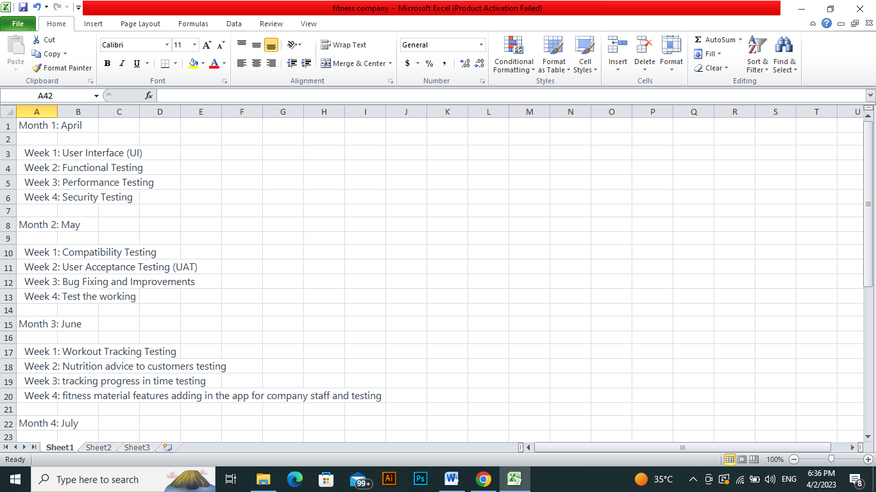

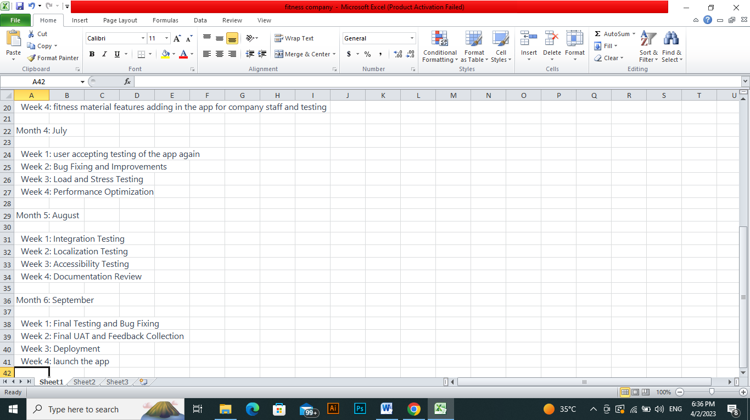

Test Plan is critical component of the mobile application development process for the fitness company. This plan will ensure that the mobile application is developed with the highest quality and meets the expectations of the stakeholders.

1. Write a 1–2-page report outlining your quality control plan and test plan for the mobile application project. In your report, be sure to explain how the quality control plan aligns with the project objectives and how it will help ensure that the mobile application meets the required quality standards. Also, explain how the test plan aligns with the quality control plan and how it will help ensure that the mobile application meets the required quality standards.

**Report:**

The Quality Control Plan defines the standards and procedures that will be followed to ensure that the mobile application is of high quality. The Quality Standards meet when the mobile application should be of high quality. These criteria will include performance, usability, security, reliability, and compatibility. The Quality Assurance Activities will include reviews, inspections, and audits of the mobile application development process. The purpose of these activities is to ensure that the development process follows the defined quality standards and procedures. The Quality Control Activities will include testing the features of the mobile application to ensure that it meets the defined quality standards like it should provide customized workout plans and nutrition advice to its customers. These activities will include functional testing, performance testing, security testing, and compatibility testing. For the quality control there must be reporting procedures to ensure that stakeholders are informed of the quality status of the mobile application.

The Test Plan defines the approach, scope, and schedule of the testing activities that will be performed on the mobile application. The following are the key elements of the Test Plan:

**Test Approach:** The Test Approach will define the types of testing that will be performed on the mobile application. These types of testing will include functional testing, performance testing, security testing, and compatibility testing.

**Test Scope:** The features and functionality of the mobile application will be tested and the devices and platforms that will be used for testing like the mobile and pcs for the development of the App.

**Test Schedule:** The schedule will include the testing milestones, such as the start and end dates for each type of testing like UI designing in 1st week of the 1st month and as the project needs to be completed in the timeframe of 6 months so we must test the activities timely in the whole project.

**Test Deliverables:** The Test Deliverables will include the test cases, test results, and defect reports. These deliverables will be used to inform the development team of the quality status of the mobile application like the features is according to their need or not.

**Conclusion:**

The Quality Control Plan and Test Plan are essential elements of the fitness company's mobile application development process. With the help of these strategies, the mobile application will be created to the highest standards and match the demands of the stakeholders. To make sure they continue to be useful and successful, the Quality Control Plan and Test Plan will be evaluated and modified as the project develops.

1. Implement the quality control plan and test plan by conducting the tests outlined in the plan. Document the results of the tests, including any defects that were identified.

## **Quality control plan and test plan by conducting the tests:**

## To guarantee that the mobile app for the fitness firm is of the highest quality and adheres to user expectations, perform routine code reviews to find any flaws or potential areas for development, to guarantee consistency and maintainability, adhere to coding standards and best practices, to find bugs early, unit test all changes to the code, test the integration of all components on a regular basis to make sure they all function as intended, test the app's usability to make sure it satisfies user expectations.

Flaws or problems found during testing like bugs in the code and errors in the execution process should be fixed right away.

**Functional Testing:**

## App is providing customized workout plans or not.

* App is providing feature of nutrition advice to its customers or not.
* App is user-friendly or not.
* App is allowing customers to track their progress over time or not.

**Performance Testing:**

* Verify that the app loads quickly and responds to user interactions promptly.
* Verify that the app can handle a large number of concurrent users without crashing or slowing down.

**User Experience Testing:**

* Conduct usability testing to ensure that the app is intuitive and easy to use.
* Conduct accessibility testing to ensure that the app is usable for all users, including those with disabilities.

**Security Testing:**

* Verify that user data is stored securely and that there are no vulnerabilities in the app.
* Conduct penetration testing to identify any potential security issues.

**Acceptance Testing:**

* Have a group of users test the app and provide feedback.
* Use the feedback to address any issues and improve the app.

During the testing phase, the following defects were identified like for certain devices, the app took a long time to load, Users with disabilities reported difficulties accessing some features of the app.